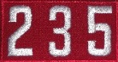
Troop Rules

Obey the Scout Oath and Law
Be respectful
No horseplay
No swearing
No yelling
Let sleeping scouters sleep
No bullying
Ask for permission before you take
Always have a buddy

